Birla Institute of Technology and Science, Pilani
CS G516 Advanced Database Systems
Lab No #0
*************************************************************************************

Introduction
Lab sheets are based on MySQL Server-8.0. Each DBMS does things differently, and no major DBMS follows the specification exactly.
SQL is divided into three major parts.
- Data description language (DDL) is used to define the structure of the data.
- Data manipulation language (DML) is used to store and retrieve data from the database.
- Data control language (DCL) is used to restrict access to data by certain users.

Installing MySQL Server on Windows-10 64-bit Version

MySQL Community Downloads
Go to the following link for download.
https://dev.mysql.com/downloads/mysql/
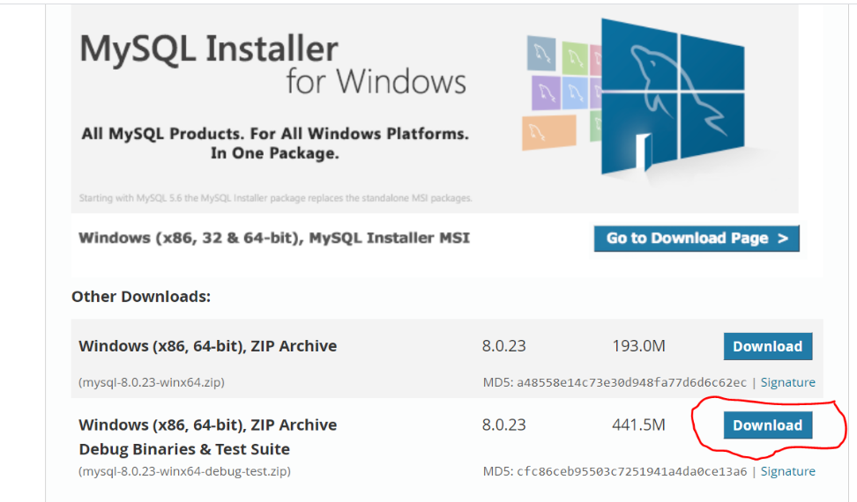
Click on download button highlighted in red color.
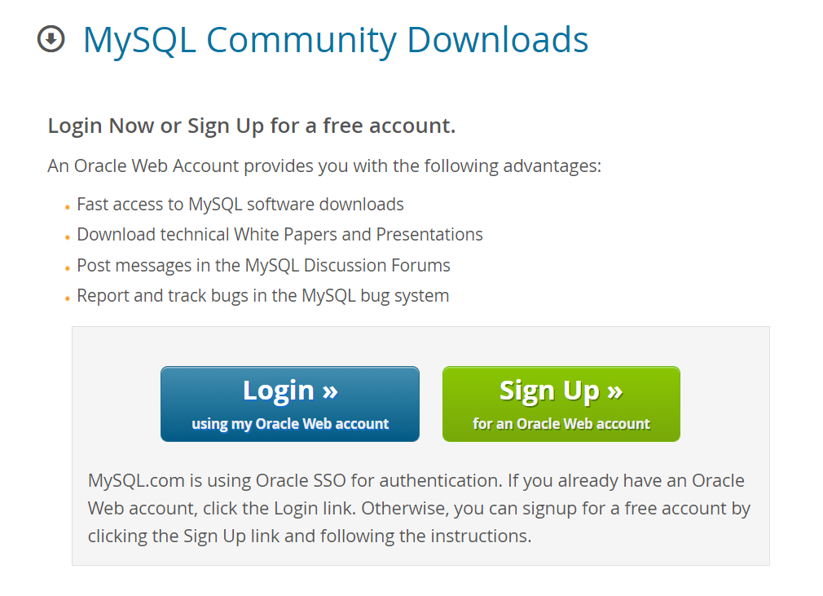
Login / signup for download the software.

Installation and Configuration of MySQL Server
Open the downloaded file and follow the instruction as shown in screenshots.
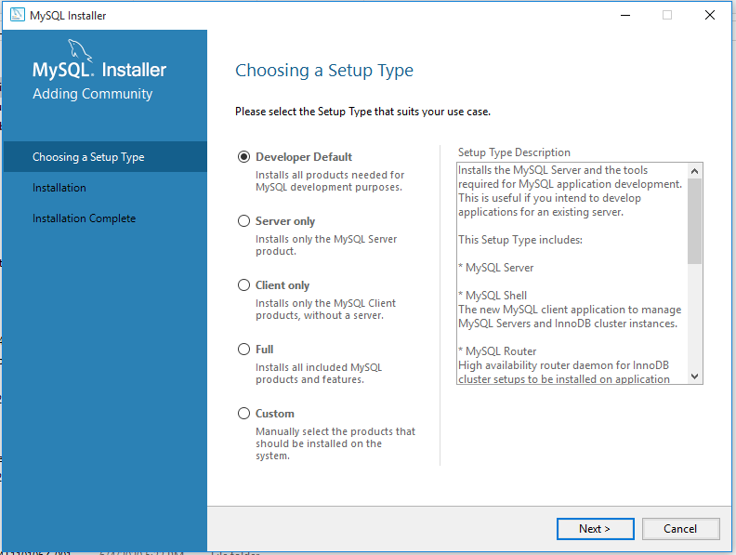
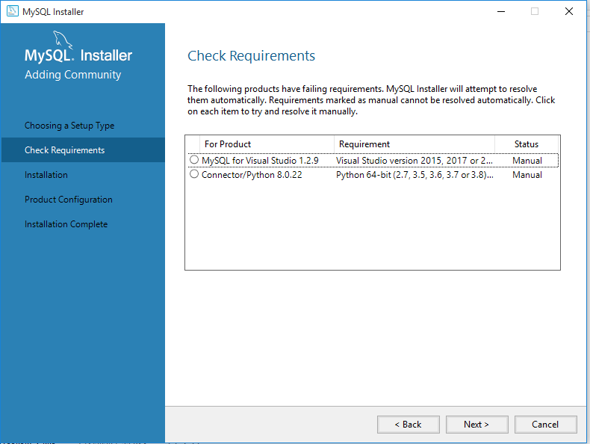
This requires some additional software’s those not needed this time. Click on next button.
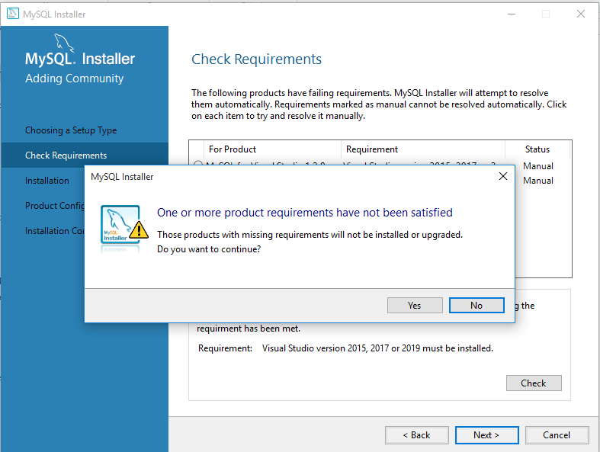
Click on “Yes” button.
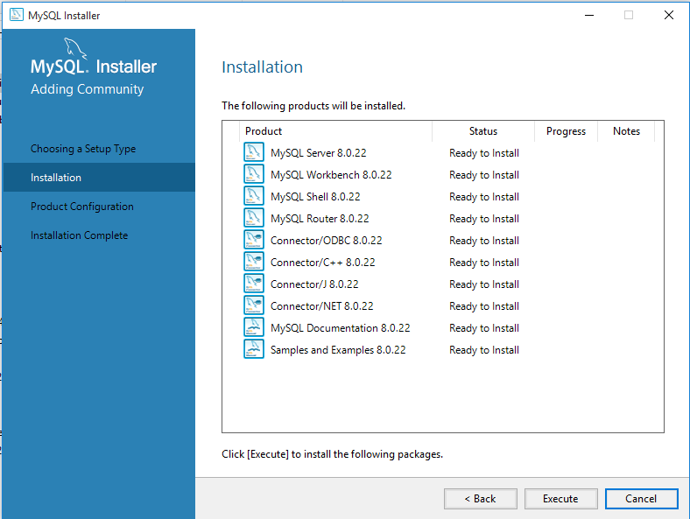
Click on “Execute” Button to begin installation of MySQL Products.
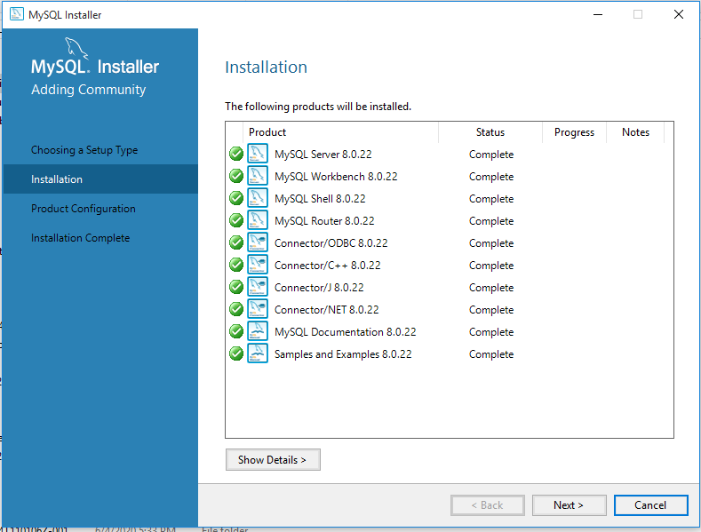
Green ticks show that products installed successfully.
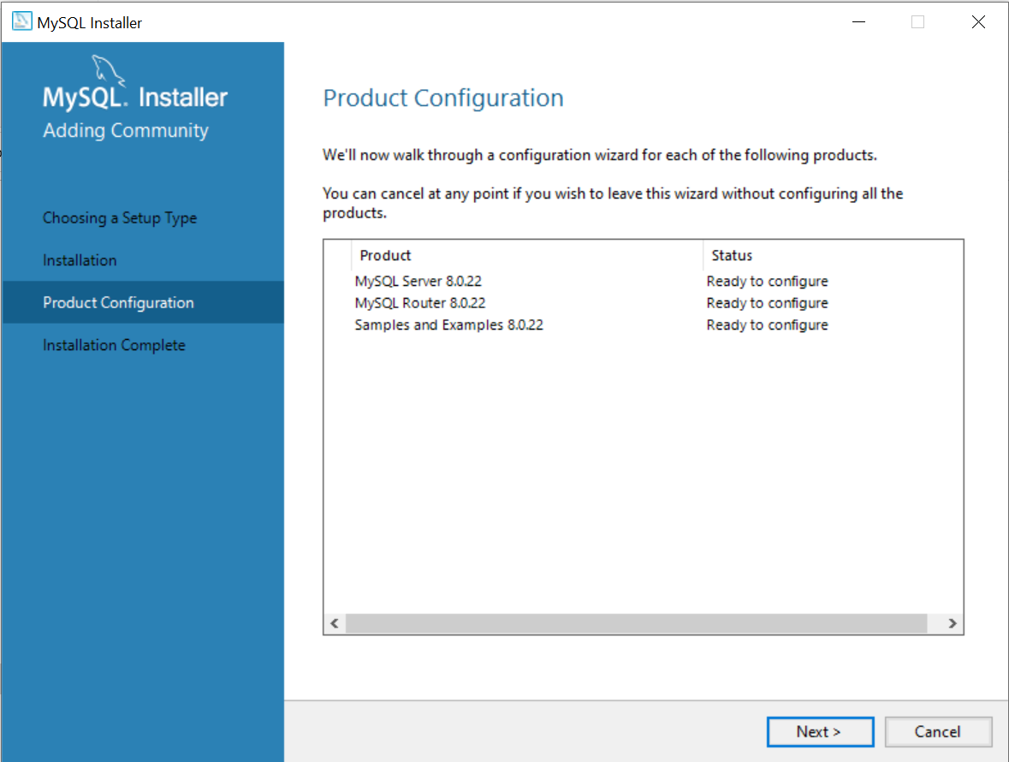
Next, we need to configure the MySQL Server and sample database. Click on next button.
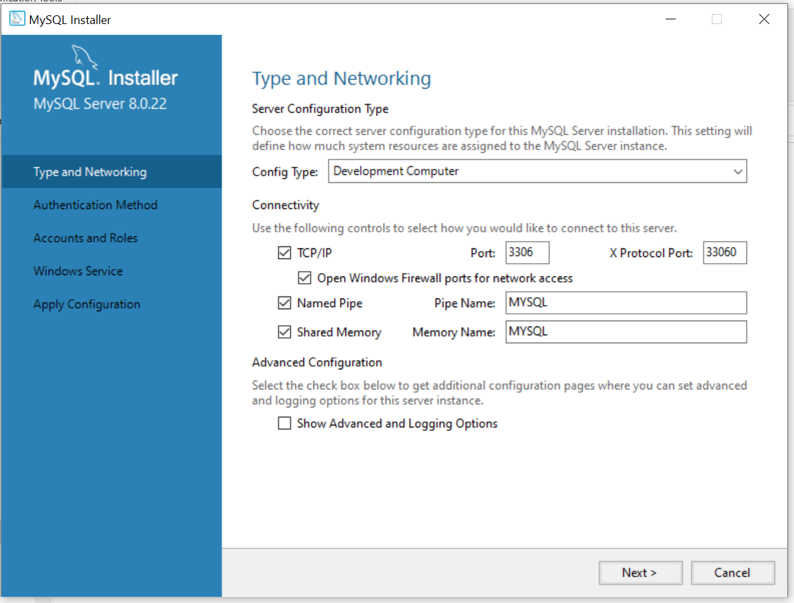
Config type should be Development Computer and remember the port number which will be useful when you are connecting from third-party applications. Click on “Next” button.
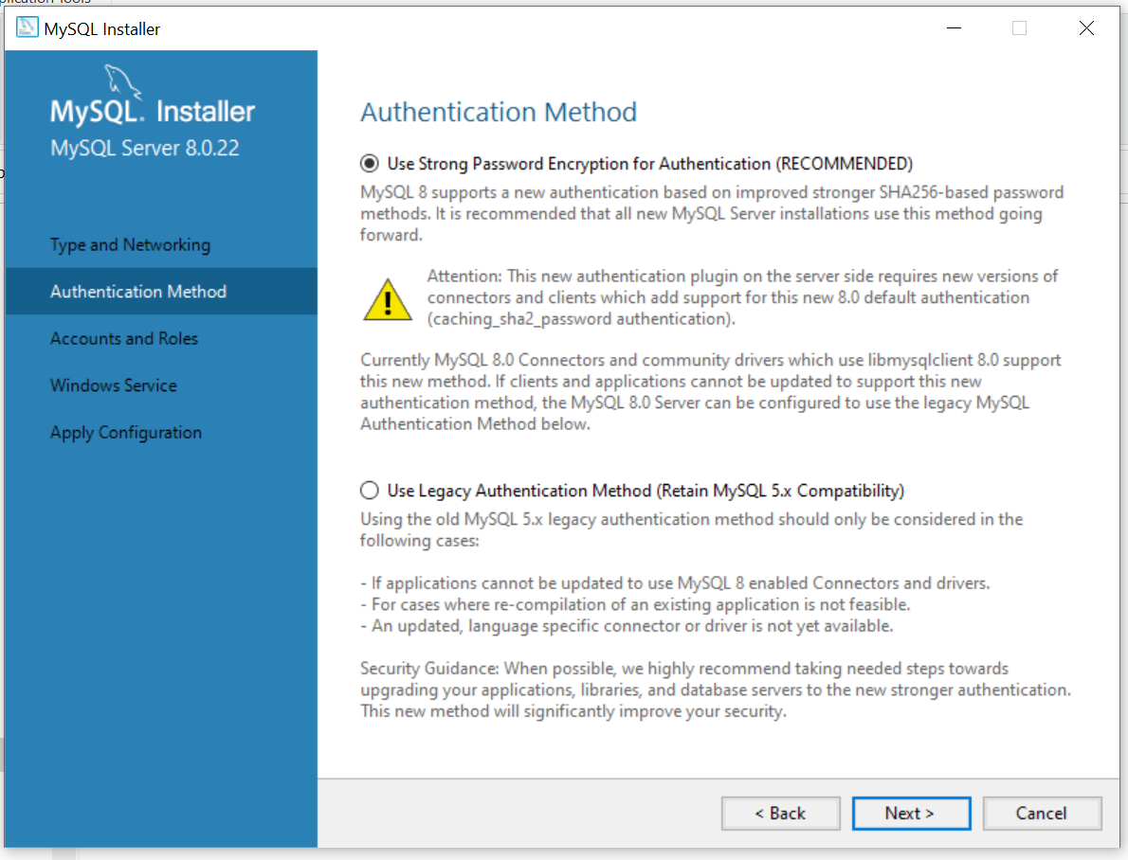
Click on “Next” Button.

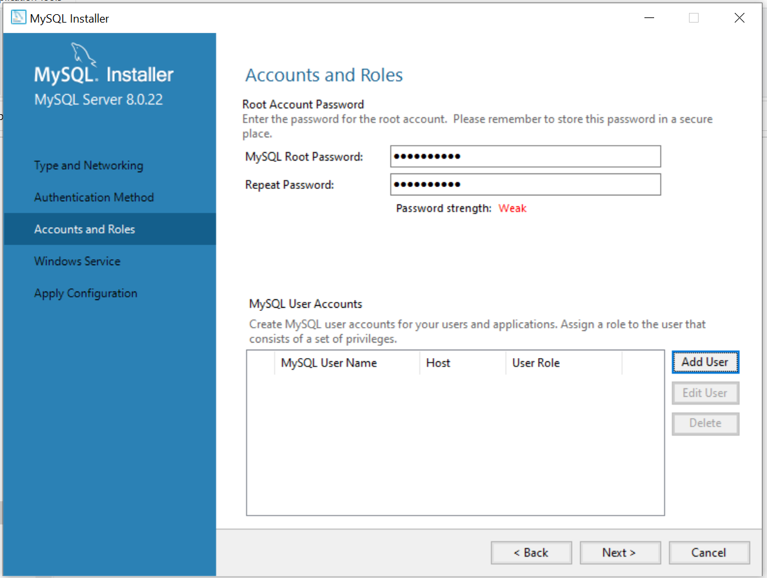
Choose a root password for MySQL server and not down it. It will require several times in future. Click on the “Add User” Button to create a user.
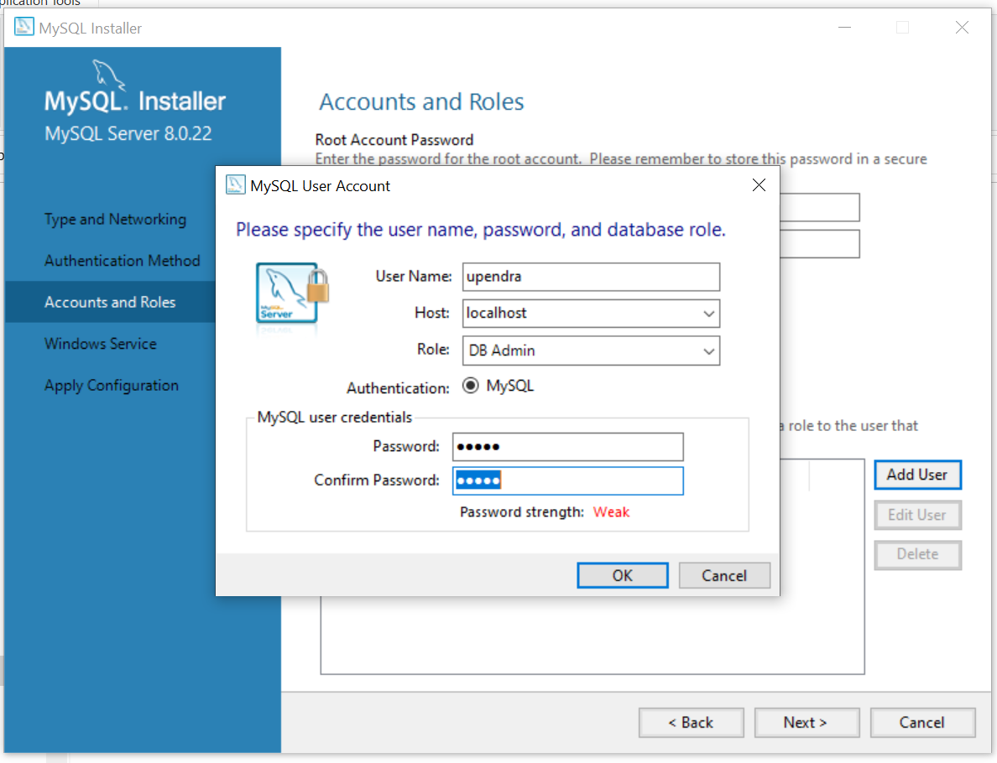
Choose username and password as per your choice and fill as shown in above screenshot and click on “Ok” button.
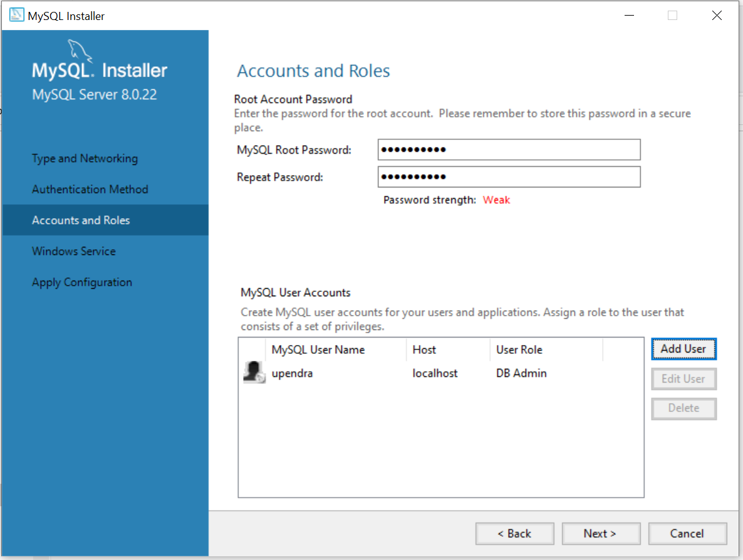
Click on “Next” button.
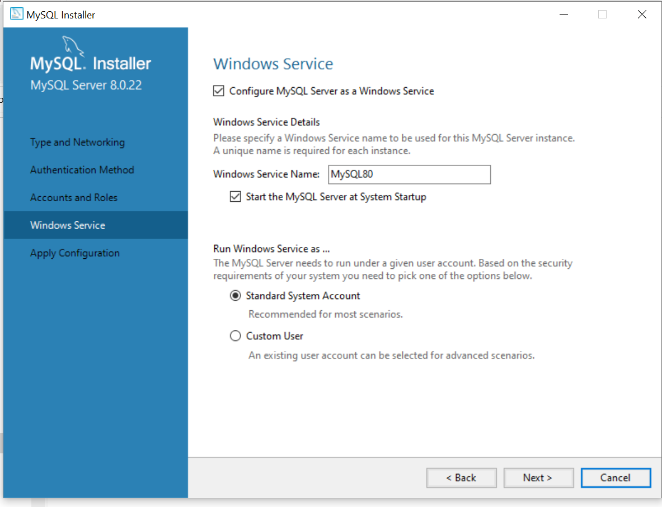
Click on “Next” button.
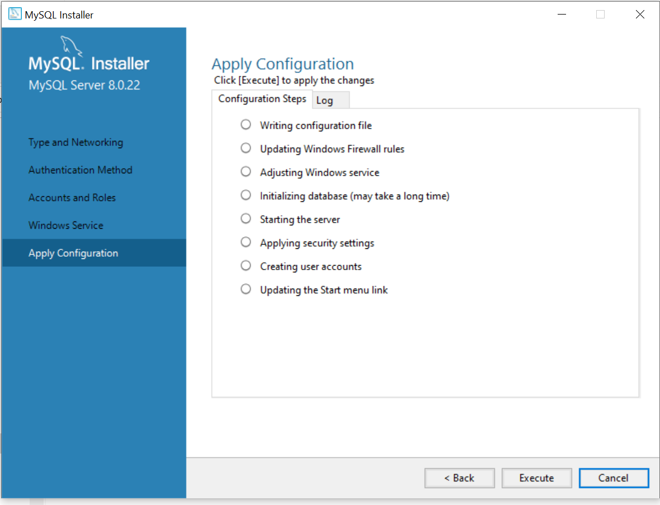
Click on “Execute” button.
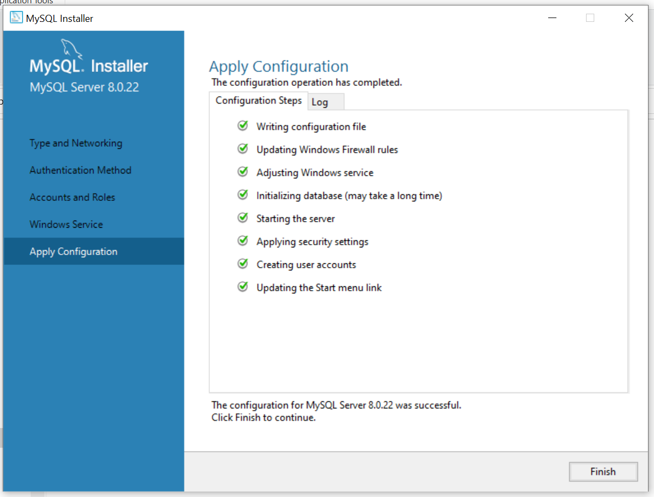
Click on “Finish” button to continue.
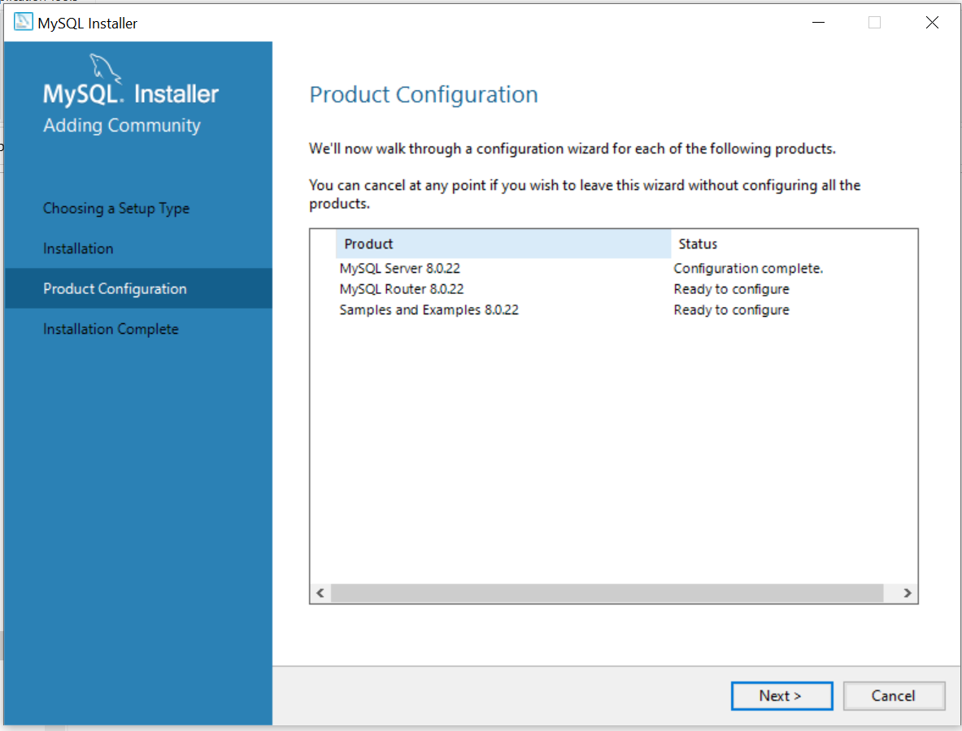
MySQL Server configuration completed. Now, click on “Next” button.
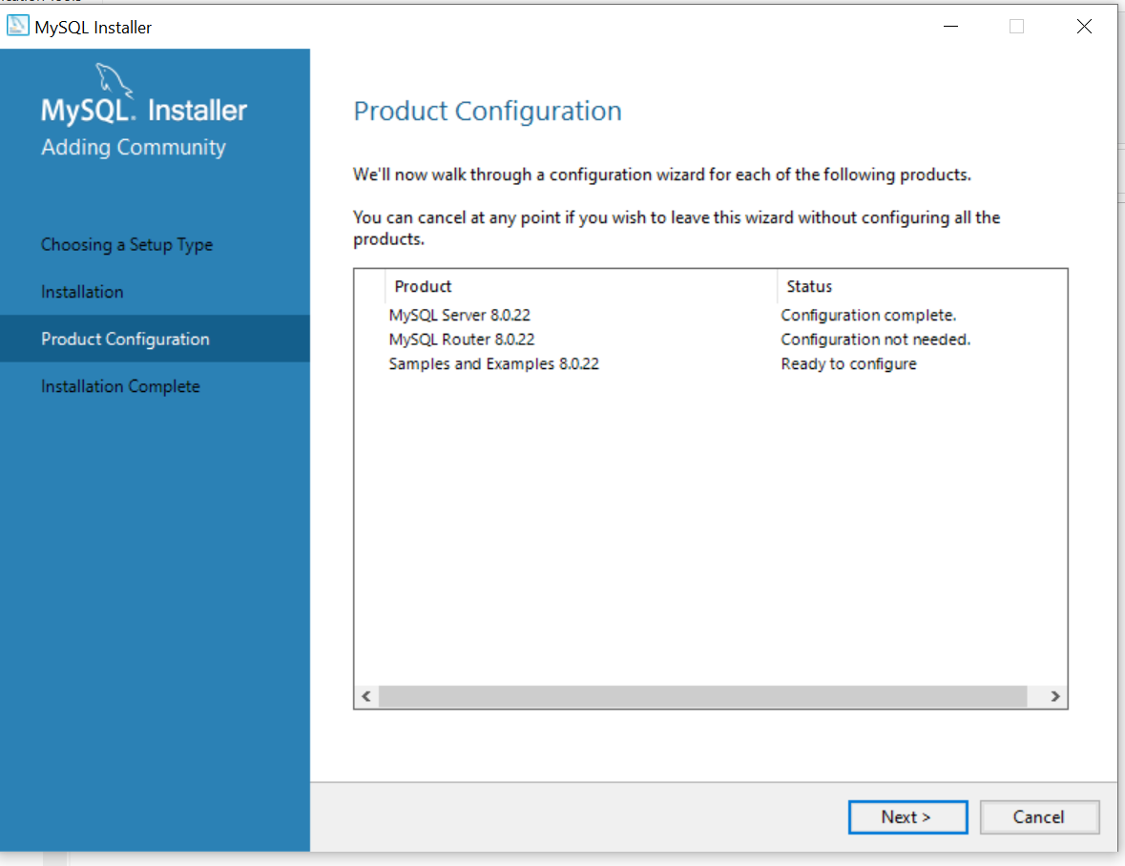
MySQL Router configuration is not needed this time. Click on “Next” button.
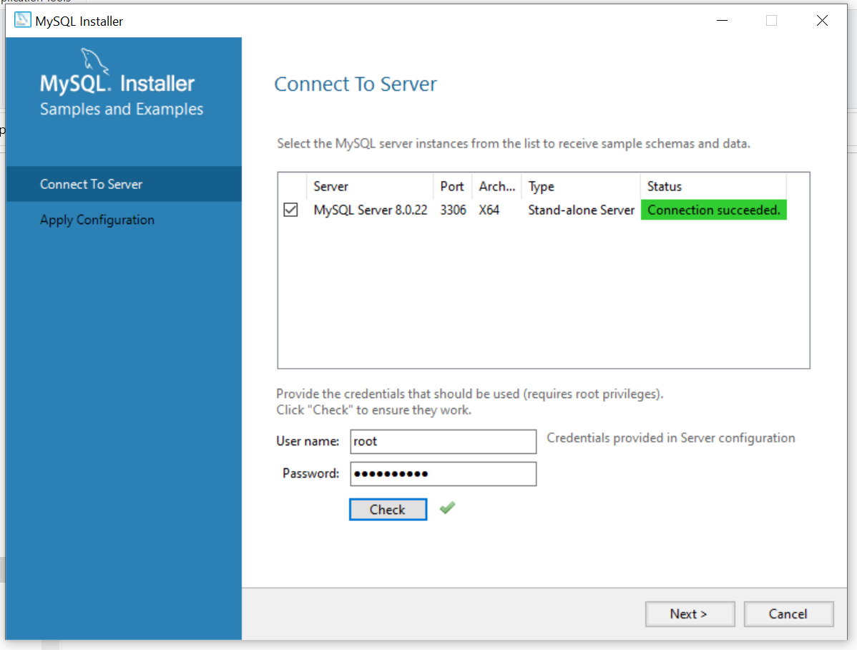
Type root password to create sample database and click on “Check” button. There will a green right tick appears. Click on “Next” button.
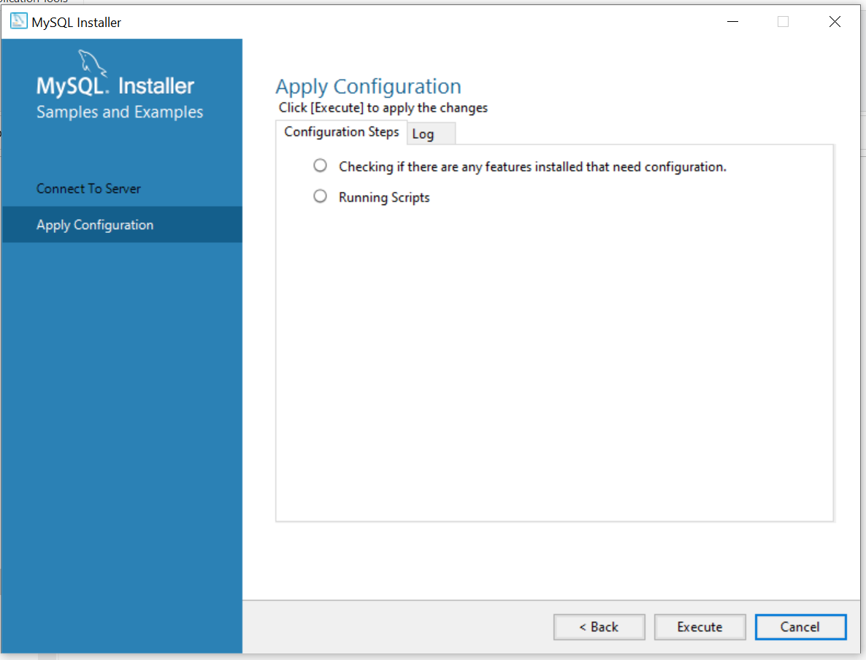
Click on “Execute” button.
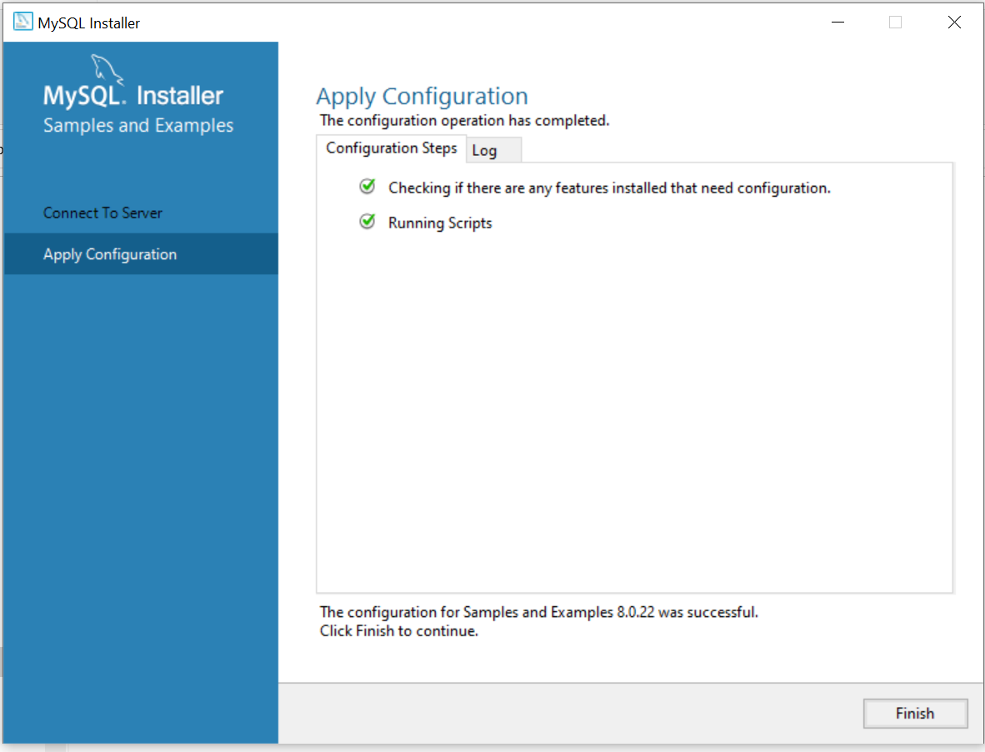
Click on “Finish” button.
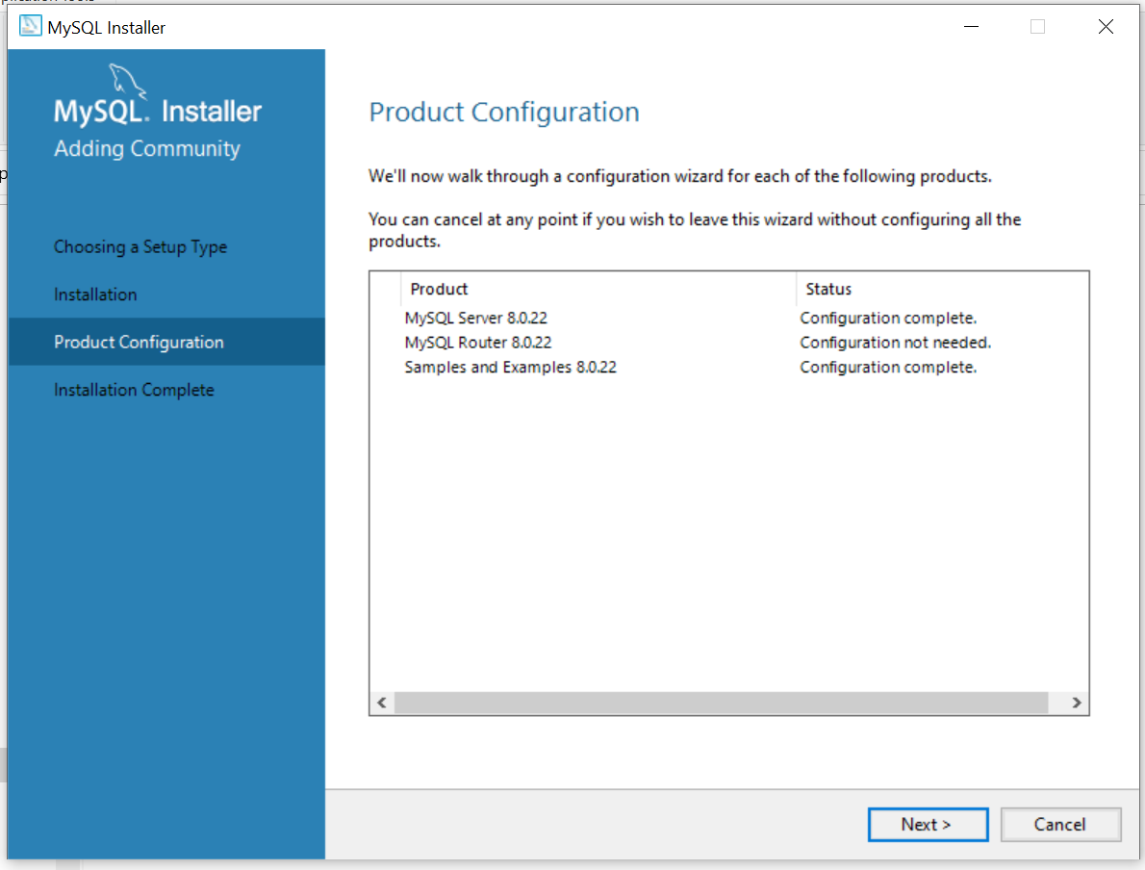
Click on “Next” button.
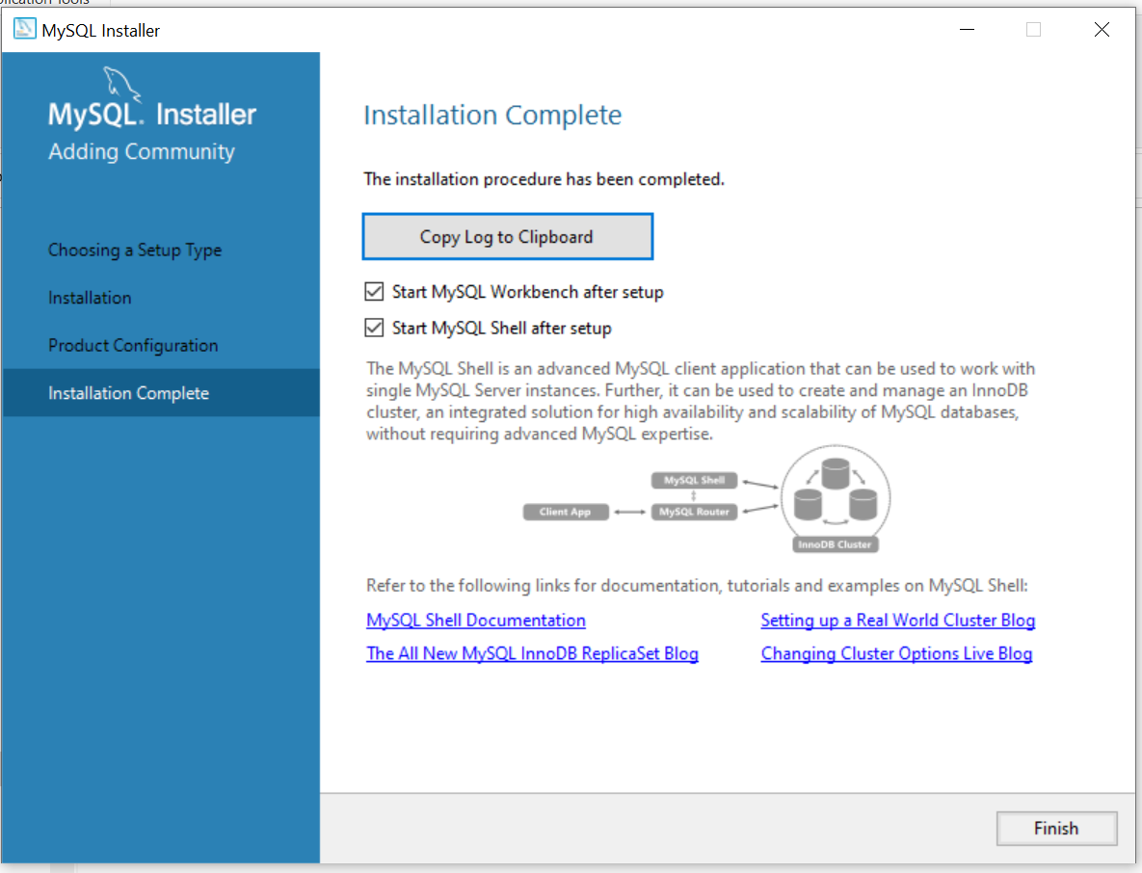
Click on “Finish” button.

Running SQL queries in MySQl Workbench

Open MySQL Workbench
Start Menu MySQL Workbench 8.0 CE.

Connecting to MySQL Server
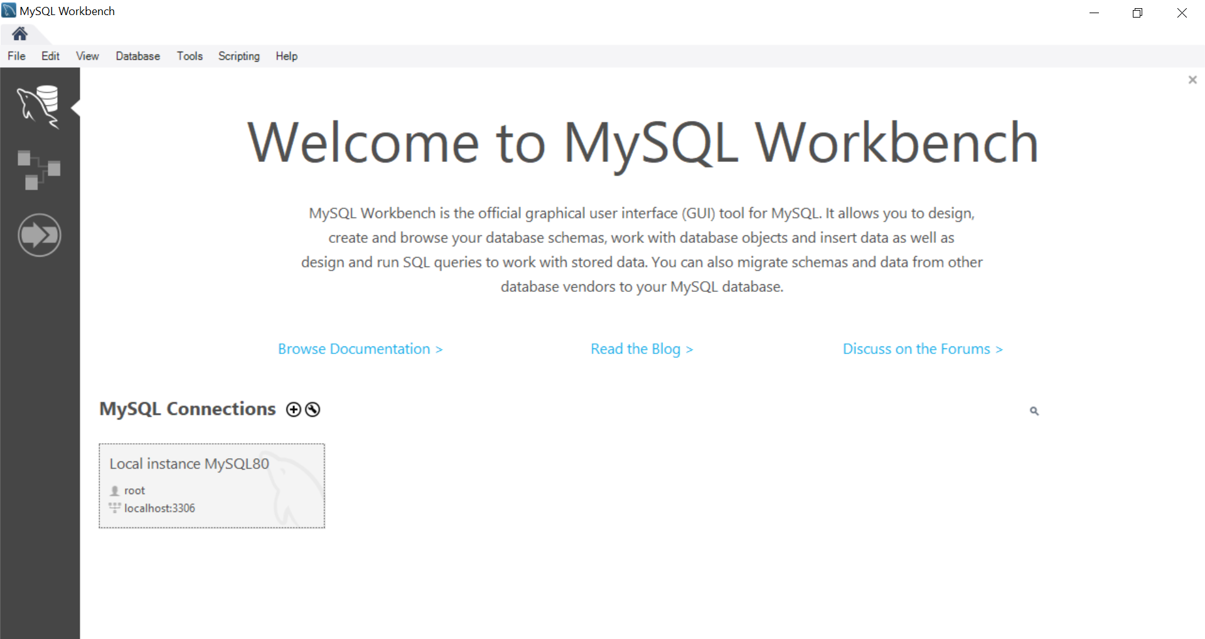
Click on area shown inside red color rectangle. A dialog box is opened asking for root password. Provide rood-password.
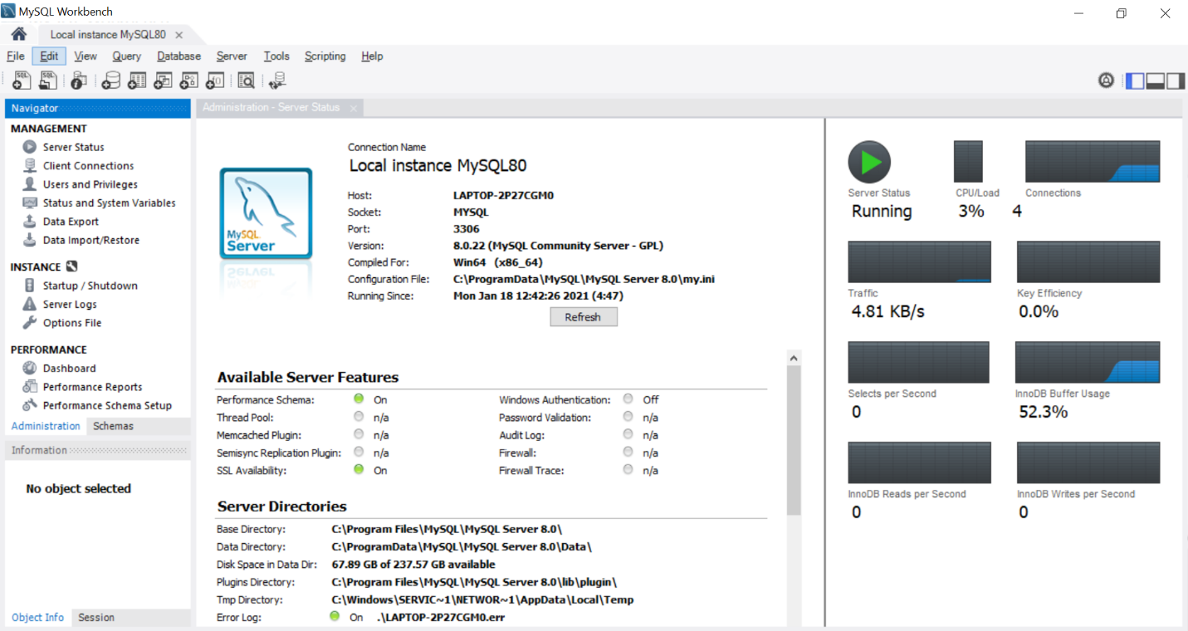
Check server status. If it shows “Running”, it means everything is installed and configured successfully.

Selecting Default Schema
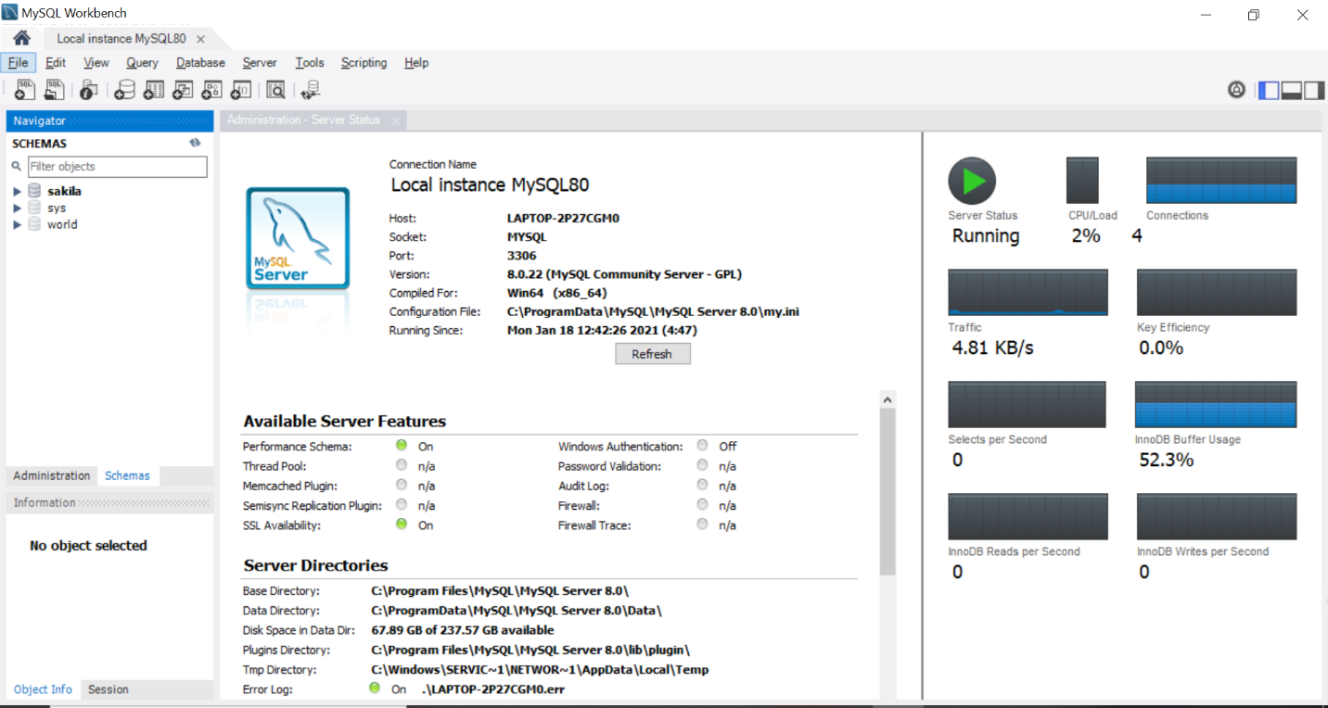
Click on “Schemas” in Navigator’s bottom pane. You will find three schemas created during installation. “Right Click” on schema name and select “Set as Default Schema”.

Writing and Executing SQL query
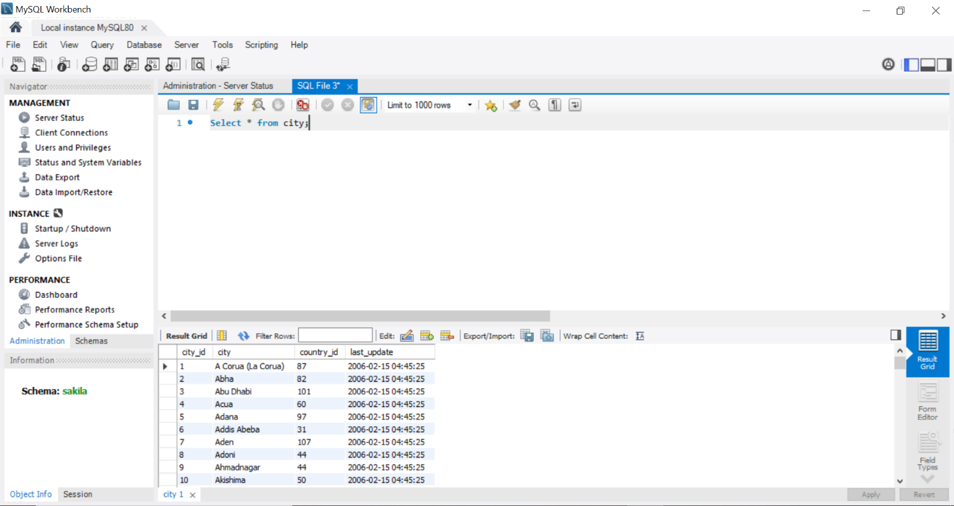
File New Query Tab or (Ctrl+T). Write “Select * from city” in workspace provided. Click on icon highlighted in red box to execute query. In this example “sakila” is selected as default schema.
***********************************END***************************************

